**j0215306**

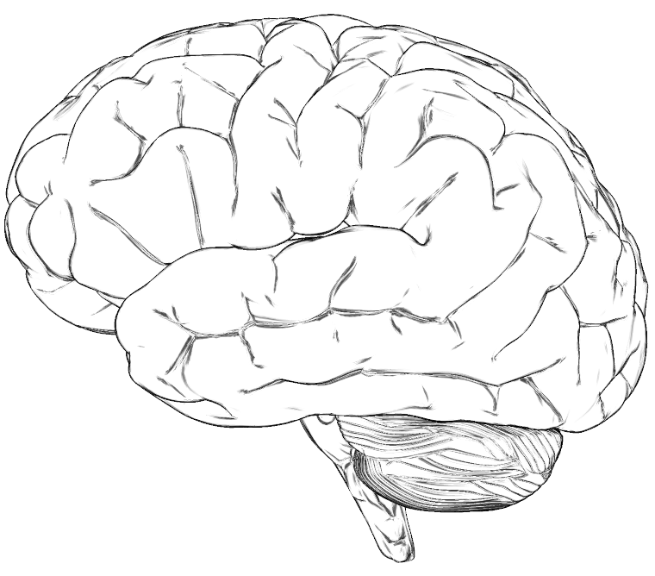

One possible activity with brain pic to teach thought-feeling relationship:

1. Have child identify different colors that represent various feelings (inlcude both positive and negative).
2. Have the child color portions of the brain that represetn how much of those feelings they have.

With the child identify thoughts that go with each feeling and write these around the brain pic in the various colors.