Sunrise…. Sunset

Stand Up Tall. Take 3 deep breaths.

On your next inhale, Stretch your arms above your head. Push your feet and legs to the ground. Reach your waist and spine to the sky.

As you exhale, bend the upper half of your body at your waist down toward your legs, as if you were diving into a pool. Bend your knees a little at first, to avoid straining your back. Bend as far as you comfortably can.

As you inhale again, open your arms wide and stand up slowly, stretching your arms to the sky.

Repeat this six to 10 times. As you inhale and stretch, think of the glowing, rising sun. As you exhale and fold, think of the setting sun. These two work together to mark the passing of the day.

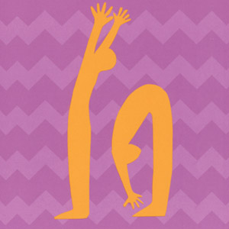

TREE POSE

Stand up straight and tall. Breathe in and out and feel your legs reaching toward the ground and your head reaching toward the sky. Look at one spot in front of you to keep your eyes steady.

Lift your right leg by bending your knee. Breathe evenly, looking at one spot in front of you. Place your right leg on your left leg, above the knee (or below the knee if that's more comfortable). Imagine roots growing from your left foot into the ground. Let your left leg be strong like the trunk of the tree. Now stretch your arms up like branches. Don't worry if you start to fall; just smile and start again from the beginning.

Breathe in and out while in the Tree pose. When you are ready to come down, lower your arms, place your right leg on the ground, and stand in the Mountain pose. Then try the Tree pose on the other side.

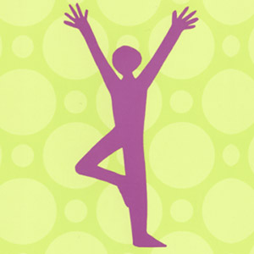

BUTTERFLY

Sit on the floor and place the soles of your feet together. Hold on to your feet or ankles, and let your knees drop toward the floor. Sit up with a tall spine.

Imagine that you are a butterfly with beautiful wings stretching out from your spine and with long antennae reaching out from your head.

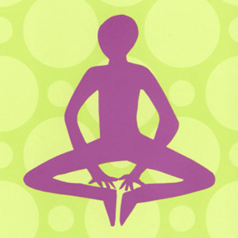

SIDE STRETCH

Stand with your legs wide apart. Take a big breath in and stretch your arms out to the sides at shoulder height. Breathe out and relax your arms and shoulders, but keep your arms at shoulder height.

Now turn your feet toward the right side. Breathe in and bend your right knee as you breathe out. Put your right hand on the floor next to your foot and reach the left arm by your ear as if you were raising your hand in class.

Feel a long stretch from your left foot all the way to the tips of your left hand. Breathe in and out softly and try to feel your body stretch a little bit more with each breath.

Breathe in to come all the way back up to standing. Now try the Side Stretch pose on the other side.

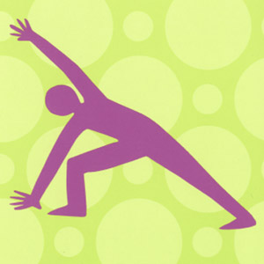

FISH

Lie down on your back with your hands on your belly. Take a breath in and breathe out slowly. Point your toes and squeeze your legs together.

Now prop yourself up on your elbows with your palms flat on the floor. Lift your belly and chest and let your head rest lightly on the floor.

Lift your chest up as if you were a fish with a colorful fin jumping up out of the water. Breathe in and out slowly.

Come down carefully on an exhalation. Rest on your back.

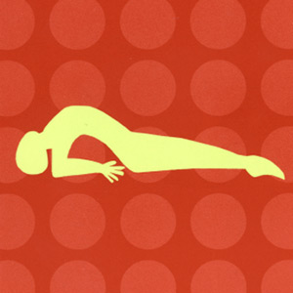

RESTING POSE

Lie down on your back in a comfortable position. Take a deep breath in and let it out slowly. Wiggle your feet, arms, and head and then let them rest while you breathe quietly.

Imagine that a warm glow is filling you up. Let the light begin at your feet and fill up your legs. Now imagine the light spreading into your belly and back. Feel the light fill up your hands, arms, shoulder, neck, and head.

As you lie very still, imagine that you are a star or a planet floating in space.

When you are ready to sit up, come up slowly. Notice how you feel.

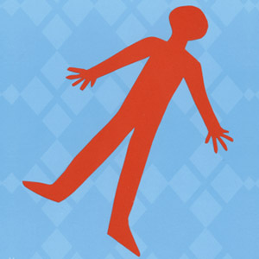

AIRPLANE

Stand up straight and tall. Take a big breath in. Reach your arms out to the sides at shoulder height as you breathe out.

Take another breath in and tip forward as you point one foot behind you. Exhale slowly. As you inhale again, lift your chest and lean forward while you lift the pointed foot in the air behind you. Try to keep your chest and back in line with your lifted foot.

Try to keep your eyes on one spot. Stretch your arms to the sides and try to balance while you breathe in and out. Now try Airplane pose on the other side.

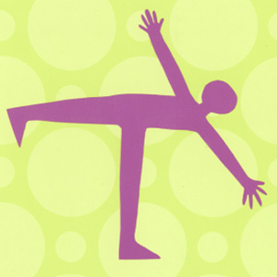

GORILLA

Stand with your legs wide apart.

Bend forward at the waist, bending your knees a little bit.

Let your arms hang down in front of you and swing your upper body back and forth like a gorilla. You can also just hang forward over your legs without swinging.

BOAT

Lie on your belly. Breathe in and relax your body as you breathe out. Bend your knees and take hold of your ankles behind you. As you breathe in, lift your head and chest and legs off of the floor. Pull your feet away from your back to stretch your chest and belly.

As you slowly breathe in and out in the Boat pose, lift your head and feet toward the ceiling. Feel the arch in your back.

When you are ready, come down slowly on an exhalation, and rest on your belly.

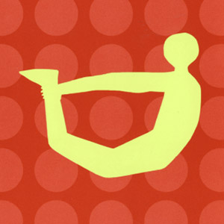

PARTNER BRIDGE

Stand up facing a friend with enough space between you to bend forward. Take hold of each other's hands or wrists. Bend forward at the waist until you are both stretching your backs long and straight. You will each pull a little bit, but not so much that you fall over. It might take a few tries to balance! You might need to bend your knees.

When you are in Partner Bridge pose, breathe slowly in and out. Try to listen to your partner's breathing also.

When you are ready to come up, stand up slowly and carefully. Thank your partner.

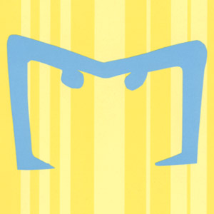

COLOR REST

Lie down in a comfortable position. Take a deep breath and then exhale slowly. Close your eyes and imagine a beautiful color. Whatever color you choose first is the right one for today.

Now imagine the color filling you up from the inside. Let the color start in your belly and spread into your legs, arms, back, and head.

As you lie still, take slow breaths in and out and keep feeling the color fill you up. When you are ready to get up, sit up slowly and notice how you feel.

